Hi Sunny –

Do you mind if we make the follow modifications to the existing charts?

A list of a few modifications are below:

1 – Lets remove the grid lines all together. I have an idea of something else to replace them with.

2 – Lets add an option named “Percentiles”. If you take a look at the database table, you will see that I have made some modifications and added many columns. The relevant columns I have added are ones corresponding to percentiles 0-100%. In actuality, they are deciles… but same thing, really. Can we add an option on the legend that will be named Percentiles and when clicked, all ten of these lines will be graphed? Lets have the color of these lines be the same grey as the grid lines were.

3 – Since we’ll be adding another value to the chart… can we alter the axes to match the screenshot below? I’m unsure how configuring the third axis for CSI Percentile will work given that its based on 11 unique values instead of only a single value that the chart could read dynamically. I suppose lets see what’s possible. (I edited the screenshot in MS Paint to represent the axes positions)

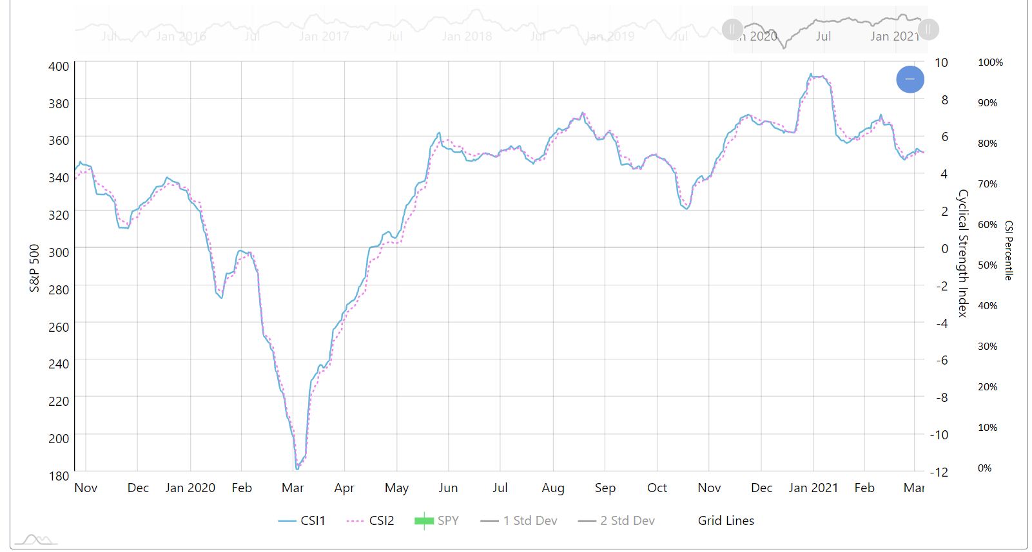

4 – Colors – Can we change the colors of 1 Std Dev and 2 Std Dev to be red instead of grey? Ideally, 1 Std Dev will be a lighter red or a shade with more opacity.

Chart 2: Bar chart

I really like what this chart communicates… but I’d like to make some modifications after thinking about it some more.

A few modifications for this chart…

1 – Can we make it so that the CSI bar (second bar) is actually one full bar instead of four segments? This way, the bar will just show the cumulative percent of all the quadrants that are selected at a point in time.

2 – Can we move the legend to the right side and copy the style in the following example:

<https://www.amcharts.com/demos/bell-curve-series/>

What is different about this style, is that the numerical value is included in the legend. Instead of a decimal with 6 decimal points… can we convert it to written percent format with only a single decimal point (e.g., 71.8%)?

3 – Can we remove the decimal percents from the bars themselves? Because they’ll now be in the legend, it no longer will make sense to have them written in the bar. Instead, can we have the following as the text in the bars: “S&P 500” and “CSI Quadrants”